EXPERIMENT 14 PPS
14.1.1//Complex number addition using class
Ans: ALGORITHM;
Step 1: Start
Step 2: Define a class Complex with attributes:
- real
- imag
Step 3: Define method initComplex()
- Read two integers from user input
- Assign them to real and imag
Step 4: Define method sum(c1, c2)
- Set real = c1.real + c2.real
- Set imag = c1.imag + c2.imag
Step 5: Define method display()
- If imag >= 0, print "real + imag i"
- Else, print "real - |imag| i"
Step 6: Create three objects:
- c1, c2, c3 of class Complex
Step 7: Call initComplex() for c1
- Input first complex number
Step 8: Call initComplex() for c2
- Input second complex number
Step 9: Call sum(c1, c2) using c3
- Store result in c3
Step 10: Call display() using c3
- Display the result
Step 11: Stop
FLOWCHART:
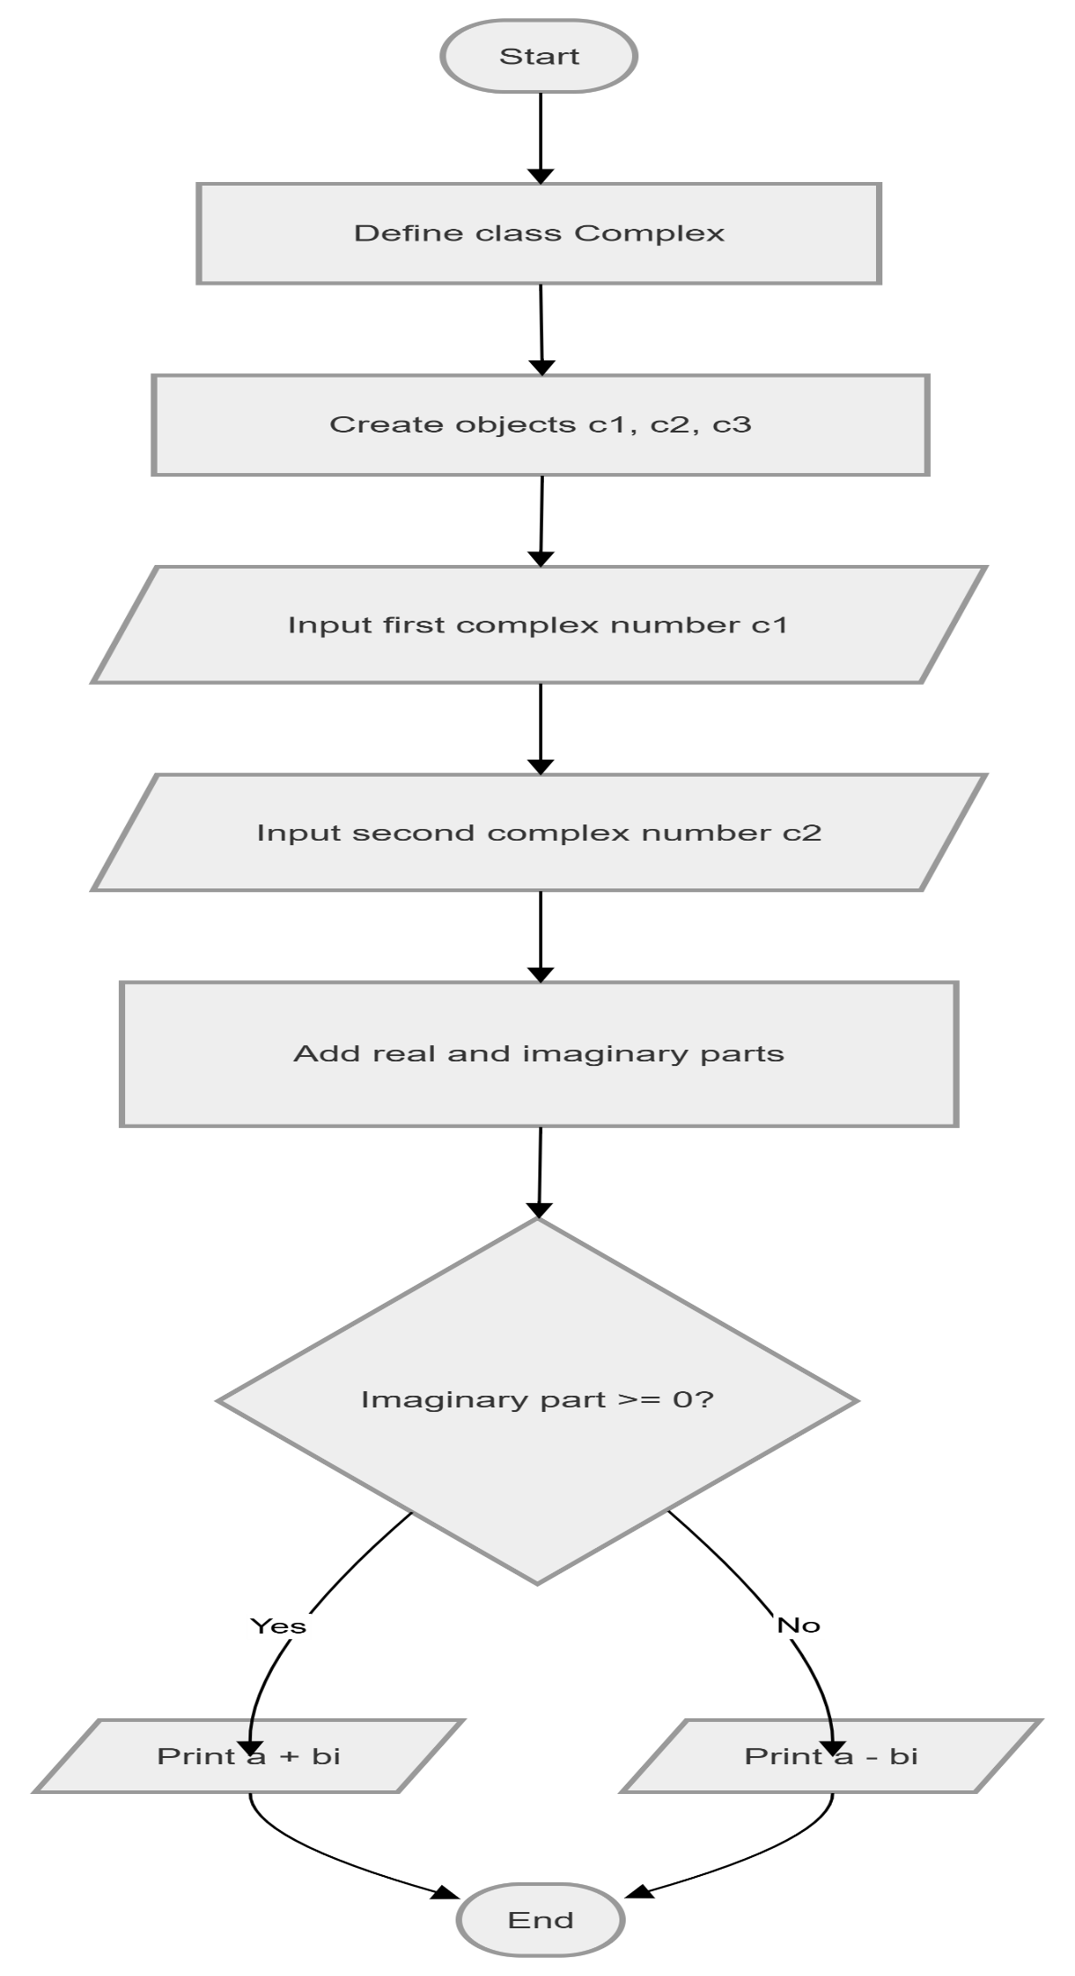

CODETANTRA:
